Bump data.

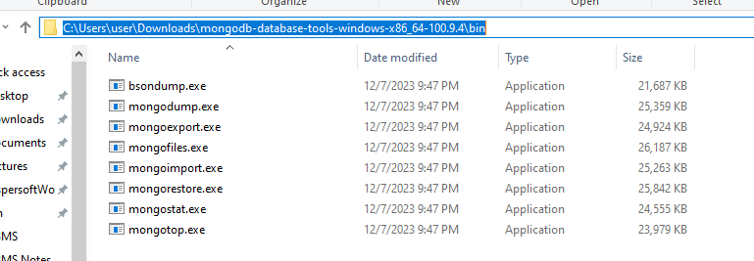

D:\DBMS\MongoDB Exercise\restaurants.json -- file path

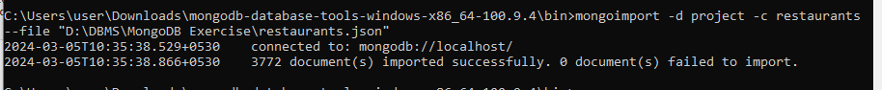

mongoimport -d project -c restaurants --file "D:\DBMS\MongoDB Exercise\restaurants.json"

Questions

1. Write a MongoDB query to display all the documents in the collection restaurants.

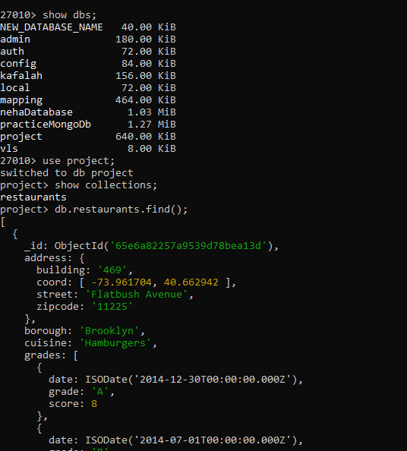

2. Write a MongoDB query to display the fields restaurant_id, name, borough and cuisine for all the documents in the collection restaurant. 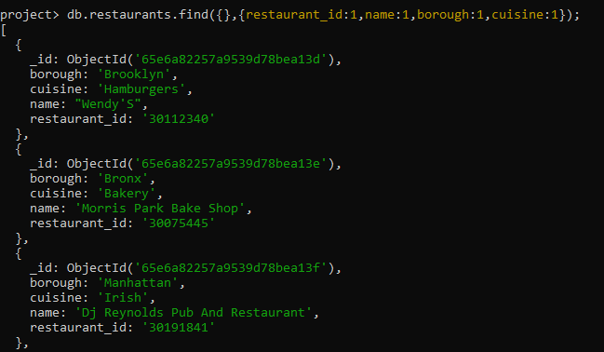

3. Write a MongoDB query to display the fields restaurant_id, name, borough and cuisine, but exclude the field _id for all the documents in the collection restaurant.

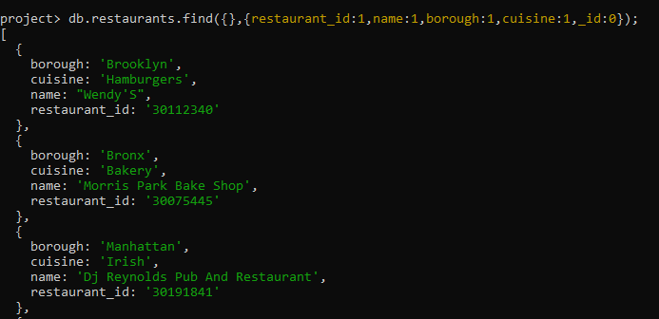

4. Write a MongoDB query to display the fields restaurant_id, name, borough and zip code, but exclude the field _id for all the documents in the collection restaurant.

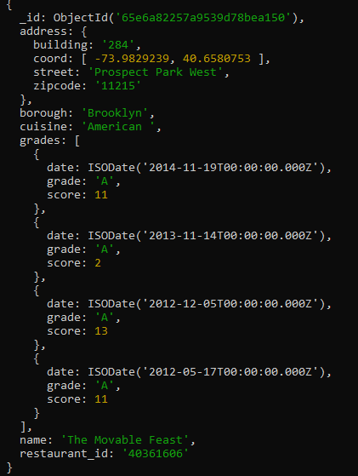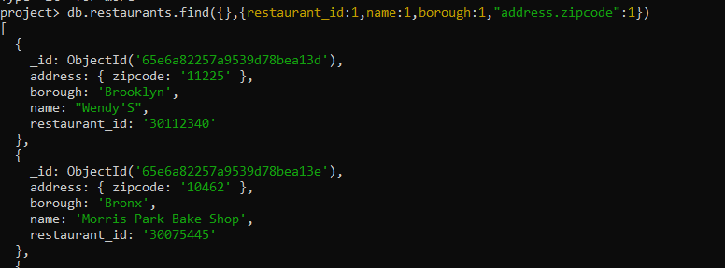

5. Write a MongoDB query to display all the restaurant which is in the borough Bronx.

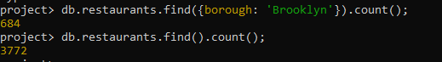

6. Write a MongoDB query to display the first 5 restaurant which is in the borough Bronx.

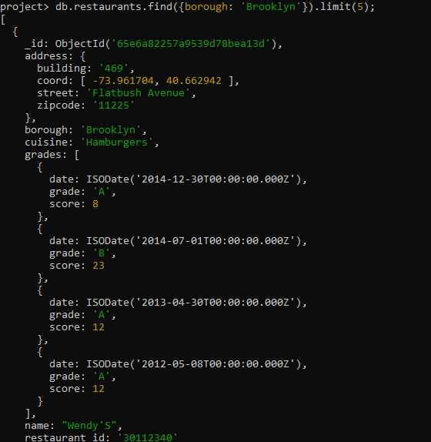

7.Write a MongoDB query to display the next 5 restaurants after skipping first 5 which are in the borough Bronx.

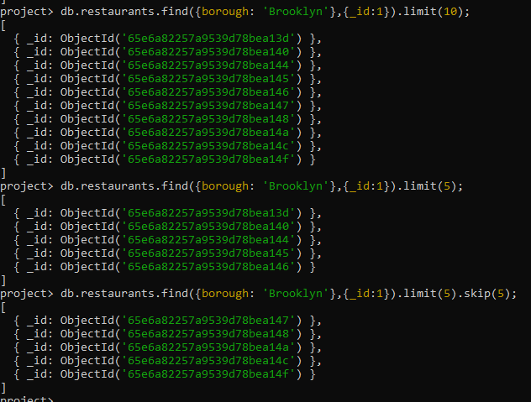

8. Write a MongoDB query to find the restaurants who achieved a score more than 90.

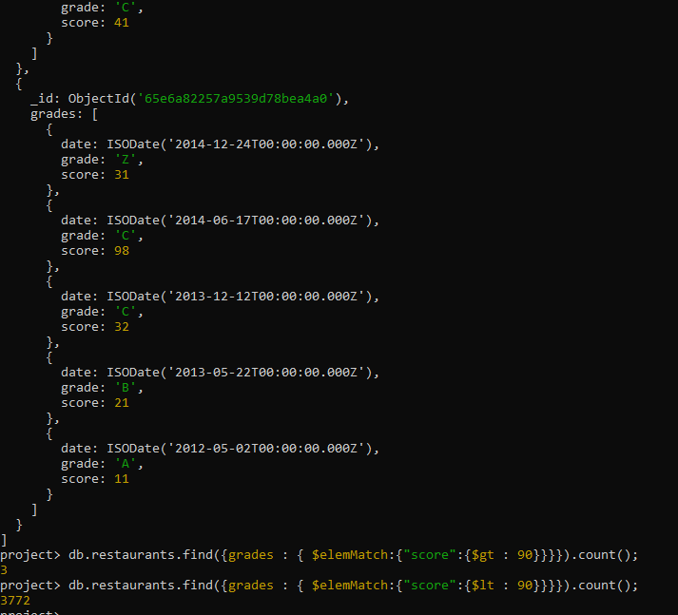

Two ways:

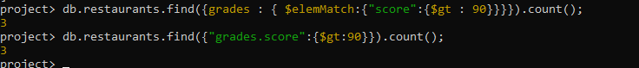

9. Write a MongoDB query to find the restaurants that achieved a score, more than 80 but less than 100.



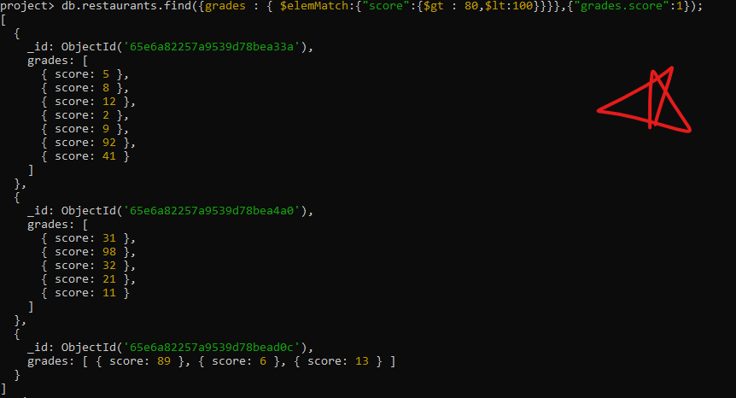

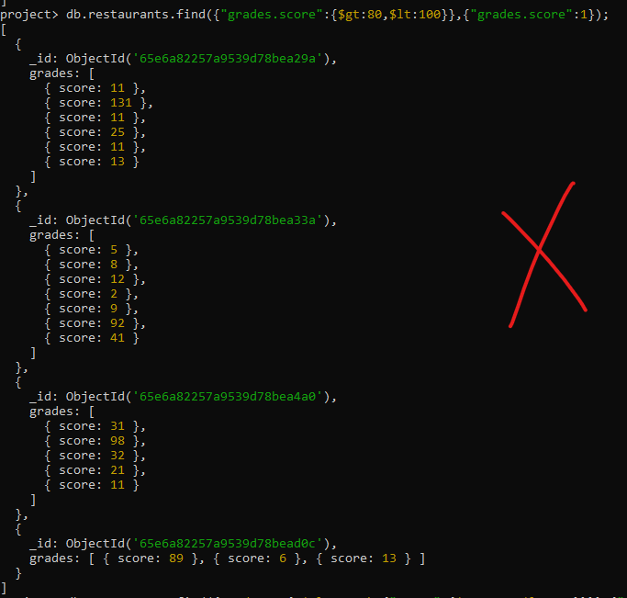

10. Write a MongoDB query to find the restaurants which locate in latitude value less than -95.754168.

